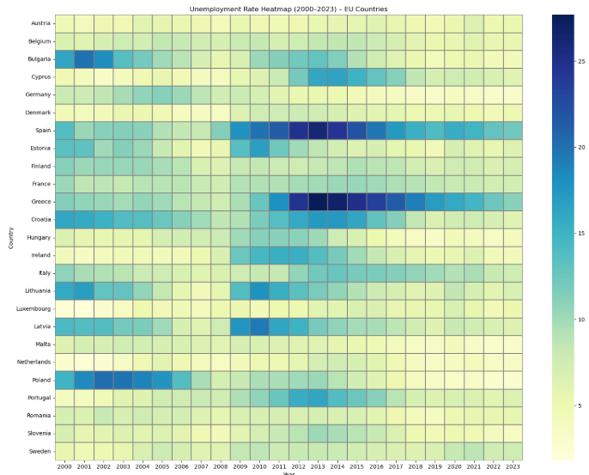**Insights: Unemployment Trends Over Time (2000 – 2023) – European Countries**

The line graph and the heatmap above illustrate unemployment trends between 2000 and 2023 in EU member states, based on data collected from the World Bank. Each line in the line graph corresponds to a different country within the EU, allowing the observers to examine the unemployment trends in general and to specify the countries that have the lowest and highest unemployment rates. The heatmap allows the observers to examine the countries in depth, enabling them to better understand each country’s unemployment trends and try to understand them through the contexts, for example 2008 financial crisis or Greek government-debt crisis.

Both visualizations illustrate distinct patterns, in terms of resilience of the labor markets. Countries such as Germany, the Netherlands and the Czech Republic consistently demonstrate low unemployment rates throughout the observed time period, suggesting stable labor markets and economies resilient to crises. Contrarily, nations like Spain and Greece experienced significant spikes after 2008 financial crisis.

In addition, Poland stands out as a country that started the period with relatively high unemployment rates, around 20% in the early 2000s. However, it illustrates a remarkable and steady decline over the time period, reaching below 5% by the early 2020s. This significant improvement highlights the country's economic transformation and labor market stabilization during Poland’s integration to the EEA.

From 2014 onward, a general downward trend in unemployment is noticeable across most EU countries, indicating recovery and improved economic conditions. This positive shift is especially visible in countries that were previously more vulnerable to economic shocks. The year 2014 stands out as a peak point for unemployment in several nations, after which steady progress is evident. Although the Covid-19 pandemic resulted in temporary increases in some countries, the unemployment rates decrease back to pre-pandemic levels in 2022 and 2023.

All in all, the overall trend suggests increasing economic integration and policy effectiveness within the EU, leading to more uniform labor market outcomes. However, the variation between countries also emphasizes the importance of national-level policies and structural economic differences. These insights point to the ongoing convergence of economic health among EU members, while also underlining the unique challenges faced by individual countries.